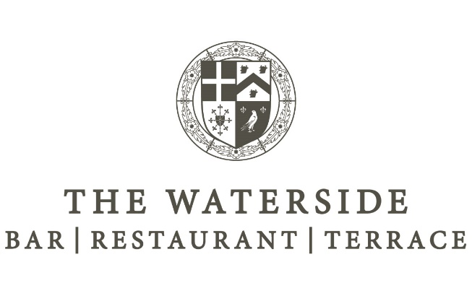

Served 12noon - 4pm
Please place your order at the Bar

TO START…

Breaded Prawns - £7.25
Breaded king prawns with a sweet chilli dipping sauce

Gyozas - £7.25
Japanese style chicken and vegetable dumplings with soy mayonnaise

Homemade Soup of the Day - £5.95 ∙ GF ∙ V
Served with a warm, crusty bread roll

Nachos - medium £5.50/large £8.95 ∙ V ∙ GF
Nachos topped with melted cheese, salsa, and soured cream

THE MAIN EVENT

SUNDAY ROASTS
Roast Topside of Beef - £17.95 (child £9.95) ∙ GFO
Yorkshire pudding, roast potatoes, seasonal vegetables and a rich gravy

Roast Pork - £17.95 (child £9.95) ∙ GFO
Yorkshire Pudding, Roast potatoes, sage & onion stuffing, seasonal vegetables and a rich gravy

HOMEMADE BURGERS

Classic Hever Burger - £12.75 ~ Bun-less option - £12.75
Char-grilled beef patty with lettuce and tomato ~ add cheddar cheese / bacon / blue cheese - £1.50

™Moving Mountains Burger - £12.75 ∙ V ∙ VEO
Plant based Burger, with chilli jam and tempura peppers ~ add vegan cheese - £1.50

Madras glazed Chicken Burger - £12.75
Char-grilled madras-marinated (mild) chicken thigh, homemade onion bhaji and mango chutney

Our burgers are served in a brioche bun with fries and homemade crunchy coleslaw

CLASSICS
Home Cooked Ham, Egg & Chips - £14.95
Our own honey roasted and hand-carved ham with 2 free-range fried eggs and chips

House Salad ∙ GFO ∙ VO
Large mixed salad with croutons and balsamic dressing, served with your choice of:
Grilled Chicken breast - £13.50 ∙Grilled Halloumi - £13.50

Homemade Vegan Chilli - £11.95 ~ two of your 5-a-day!
Lentil bean and vegetable chilli with steamed rice, home baked tortilla chips and a cucumber salsa

HOT SANDWICHES
Served in a brown baguette or white ciabatta with homemade crunchy coleslaw and fries

Hot Roast Sandwich - £11.95 ∙ GFO
Roast Beef & Horseradish or Roast Pork & Stuffing

Jumbo Fish Finger - £10.95
Two jumbo pollock fish fingers served with tartar sauce and lemon

Moroccan Falafel - £11.50 ∙ GFO ∙ V
Spiced chickpea, apricot and red pepper falafels with harissa mayonnaise

Hever Kings Club - £12.25 ∙ GFO
Triple layered sandwich with bacon, tomato, cucumber, grilled chicken, lettuce and egg mayonnaise

All Day Breakfast Sandwich - £5.75 ∙ GFO
Hot crusty roll, or white or wholemeal bloomer bread, with one of the following:
2 Cumberland sausages, 3 rashers of back bacon or 2 fried free-range eggs

SIDE DISHES

Chips - £3.75 / large £4.95 ∙ V ~ Cheesy chips - £4.75 / large £5.95 ∙ V ~ Homemade beer battered

onion rings - £4.95 ∙ V ~ Garlic ciabatta bread - £3.50 ∙ V ~ Cheesy garlic ciabatta bread - £4.50 ∙ V

~ Side salad - £3.95 ∙ V

SMALLER DISHES
(Ideal for younger children) - £6.95

Chicken goujons with chips and cucumber and tomato ~ Fish fingers, chips & peas
Cumberland sausages, chips and beans ∙ V

Please ask a member of staff for today’s dessert of the day

Allergies & Intolerances - please speak to a member of staff before ordering if you have any allergies.
All our dishes may contain traces of nut or other allergens. Chips/Fries are cooked in the same fryer as foods with other allergens.

V = Vegetarian ~ VE = Vegan ~ VEO = Vegan option available ~ GF Gluten Free ~ GFO Gluten Free option available

There may be times when some ingredients on our menu need to be substituted, however we will always do our best
to avoid this but if necessary, ingredients will be replaced without sacrificing quality.

