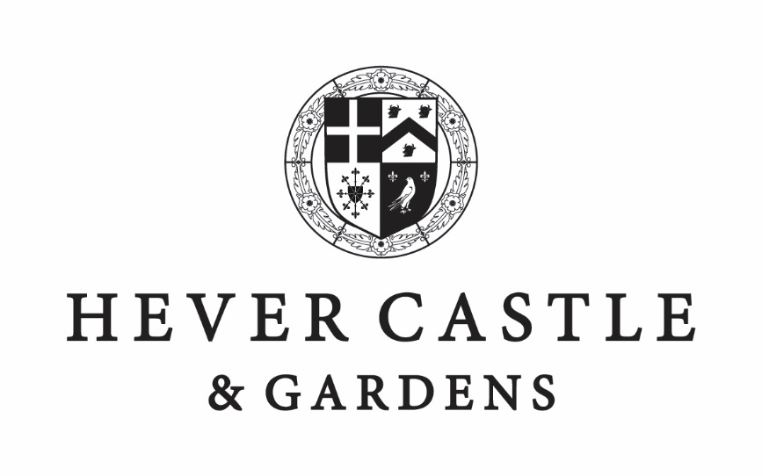

ITALIAN GARDENS
ROMAN TRAIL

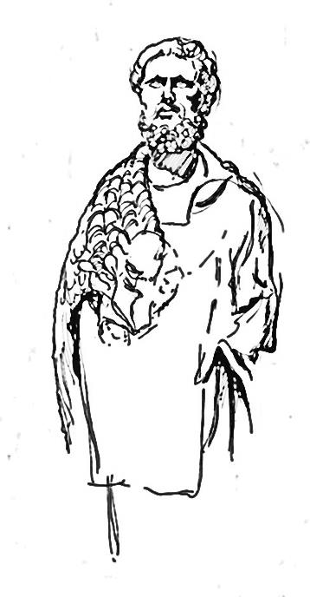
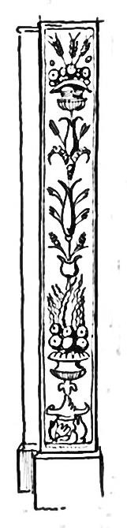
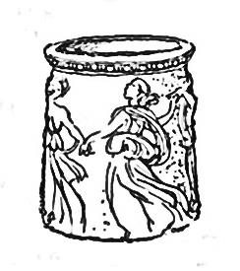

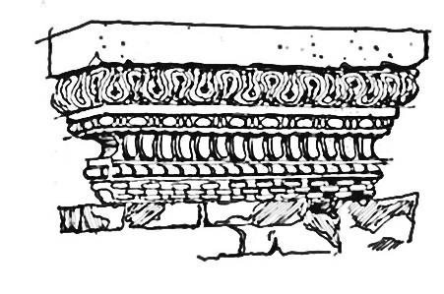
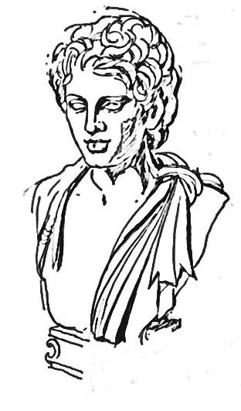
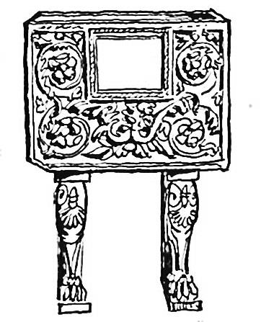



Remember to bring your pencil

VENUS AND CUPID
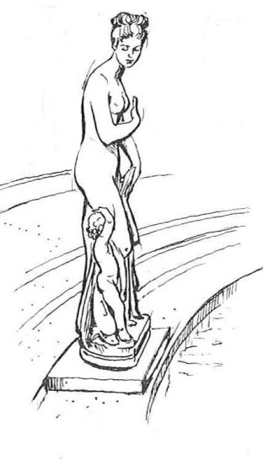
“I am Venus and this is my son Cupid. I am the goddess of love. My son is the god of attraction and affection”.

Cupid was stung by bees when he stole honey from their hive. He cried and ran to his mother Venus asking why such a small creature causes so much pain. Venus laughed, and pointed out that he too was small, and yet delivered the sting of love with his arrows.

Have a go at drawing Cupid with his arrow.


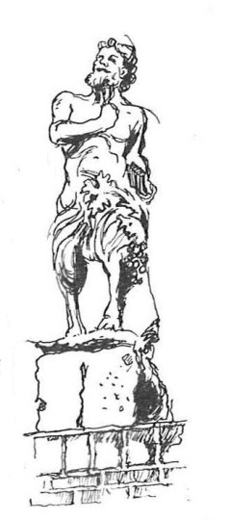

FAUNUS

“I am Faunus, god of the forest, plains and fields. I am one of the oldest Roman gods. My Grandfather was Saturn, the god of agriculture.”

Have a look at his legs. What animal are they from?

In Greece, Faunus was known as Pan. Can you see the pan pipes in
his hand?

HERCULES

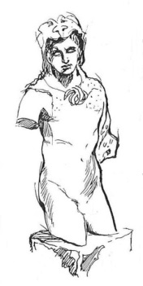
“I am Hercules, the son of Jupiter. I am most famous for my strength”.

Hercules had to undertake twelve labours, or tasks. The first was to destroy the monstrous Nemean Lion. It had golden fur which could not be penetrated by swords or arrows, and claws that could tear through armour. Hercules strangled the lion with his bare hands and wore its skin as a helmet.

Have a go at designing your own helmet below.

ROMAN SENATOR
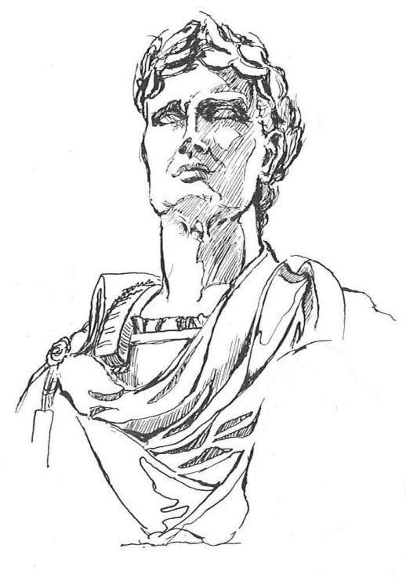

Many of the ideas and structures of Ancient Roman government became the basis for modern democracies.

It was controlled by wealthy members of society known as patricians. These leaders could be elected to the Senate and were able to vote on laws and authorised war, building projects, taxes, and other matters of public policy.

Can you find this statue of a Roman Senator?

Do you think the laurel wreath on his head tells us that he was an important man?
AMPHORAE

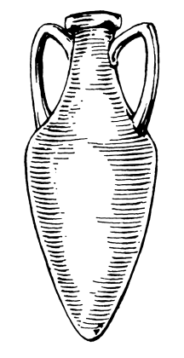

See if you can find the amphorae, or storage jars, hidden in the Italian Gardens.

These jars were used to store wine, olive oil and other foodstuffs.

COLUMN
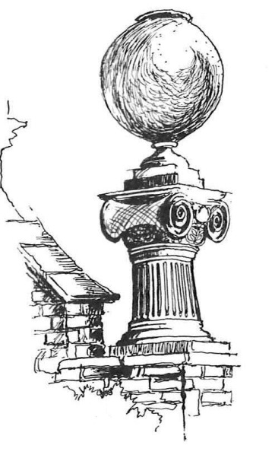

See if you can find this storage jar and column in the Italian Gardens.

What type of column is the storage jar is sitting on?

Clue: see below for three types of Roman column

Can you see any fancy Corinthian columns as you walk around the Italian Gardens?

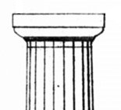 | 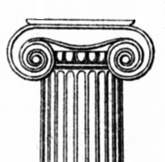 | 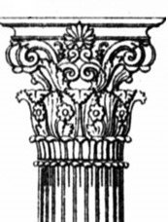
Doric | Ionic | Corinthian
VICTORY
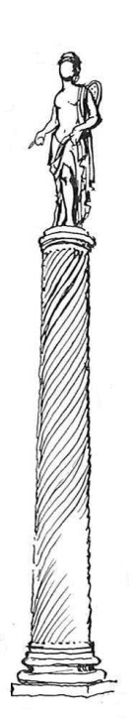

“I am Victory, an important part of Roman society. I am the symbol of victory over death and determined who would be successful during war. I appear on Roman coins, jewellery, and architecture”.

Have a go at designing a coin or a piece of jewellery using the image of Victory.


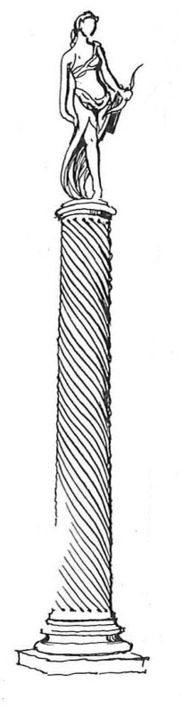

DIANA

“I am Diana. Have a look at the bow in my hand. What do you think I am the goddess of?”

Clue: Diana is associated with wild animals and woodland

BACCHUS

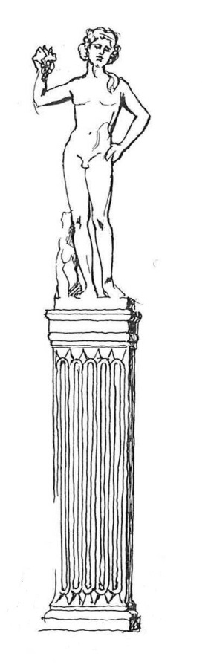
“I am Bacchus. Have a look at the fruit I am holding in my hand. What do you think I am the god of?”

Clue: You can make this drink from the fruit.

Bacchus wandered the world for many years, going as far as India to teach people how to grow vines. He is often seen in a tiger-drawn chariot, surrounded by dancing ladies and satyrs (half goat, half man) to commemorate his successful return.

Have a go at drawing your favourite fruit below.

PEDIMENT

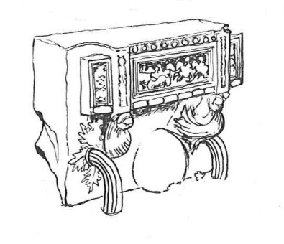

Can you find this chair in the Italian Gardens?

It is called a sella curulis. The senior Roman magistrates would sit on this. The battle scene shows that the most important duty of the government in the Roman era was to ensure peace.
APOLLO

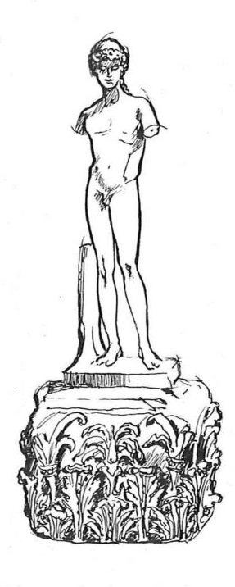

“My name is Apollo. I am the son of Jupiter, and my twin sister is Venus. I am the god of the sun.”
.

One of Apollo's daily tasks was to harness his chariot with four horses and drive the Sun across the sky.

Have a go at drawing Apollo’s chariot pulling the sun.

Illustrations © Robert and Jean Ogg 1969

hevercastle.co.uk

